**62. Use Multiple Conditional Dependencies**

--- **note** – we will learn, how we can manage if we have multiple dependencies. Using tags we can manage multiple dependencies.

--- tree

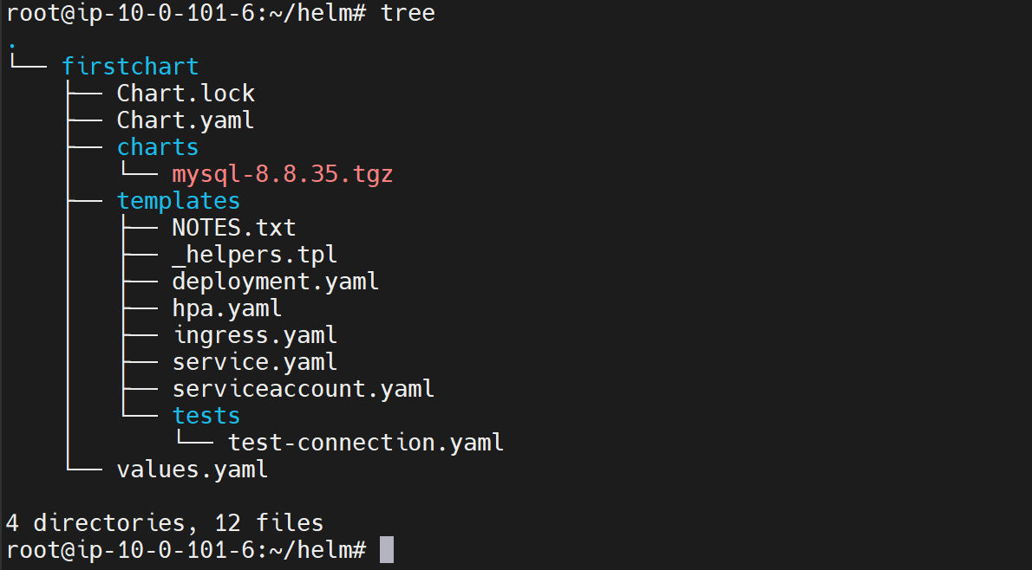

--- values.yml

autoscaling:

  enabled: false

  minReplicas: 1

  maxReplicas: 100

  targetCPUUtilizationPercentage: 80

  # targetMemoryUtilizationPercentage: 80

nodeSelector: {}

tolerations: []

affinity: {}

**tags:**

**enabled: true**

--- Chart.yaml

# This is the version number of the application being deployed. This version number should be

# incremented each time you make changes to the application. Versions are not expected to

# follow Semantic Versioning. They should reflect the version the application is using.

# It is recommended to use it with quotes.

appVersion: "1.16.0"

**dependencies:**

**- name: mysql**

**version: "~8.8.0-0"**

**repository: "http://charts.bitnami.com/bitnami"**

**tags:**

**- enabled**

**- name: apache**

**version: "~8.8.0-0"**

**repository: "http://charts.bitnami.com/bitnami"**

**tags:**

**- enabled**

**# Install app**

--- helm install firstapp firstchart